VK3NX – LX1DB 24 GHz CW QSO REPORT

1st VK-LX CW QSO on 24 GHz

DATE : 27th April 2014 0530-0550z

- Wx at VK3NX
  - 60% humidity
  - Light cloud
  - Windy 20-25 km/hr gusts

- Wx at LX1DB
- Temperature was 11°C and dew point 4°C so low humidity
- Spreading of signal 120Hz during QSO

Elevation @ V3NX
- @0530 = 9.2 Degrees START QSO
- @0550 = 5.5 degrees END QSO

Loc at VK3NX QF21CT
Loc at LX1DB JN49CO

Great circle Distance = 16324.3 km .. New VK and world CW 24GHz record.

Equipment VK3NX:

- 2.4 m Solid dish (Andrews)
- 11.5 W Kuhne SSPA (10 W at feed) short WR42 flexible W/G to W/G Switch (~0.5dB loss)
- Feed: Super VE4MA choke flange with Circular to rectangular transition (WR42)
- W/G switch: “EVENTS HORIZON”
- LNA @ feed
  - Kuhne 1.5dB NF 27 db gain + DB6NT design (homebrew) NF= Max 2.0dB Gain = 11.5dB
  - Total gain is 38.5dB in “feed box”
- LMR240 with Radiall 18GHz connectors for short run on Tx and Rx from “feed box” to transverter
- Transverter = Thales 26 GHz units running 1296 MHz IF. Then down-converted to 144MHz IF. IF driver IC-7700
- Kuhne 24 GHz W/G filters on Rx and Tx ports of Thales unit. (Absolutely necessary due to very poor image rejection ~4dB only with 1296 MHz IF)

Perfomance:
- Best Moon noise measured at 2.2dB
- Moon noise at time of sked = 1.8dB and falling!

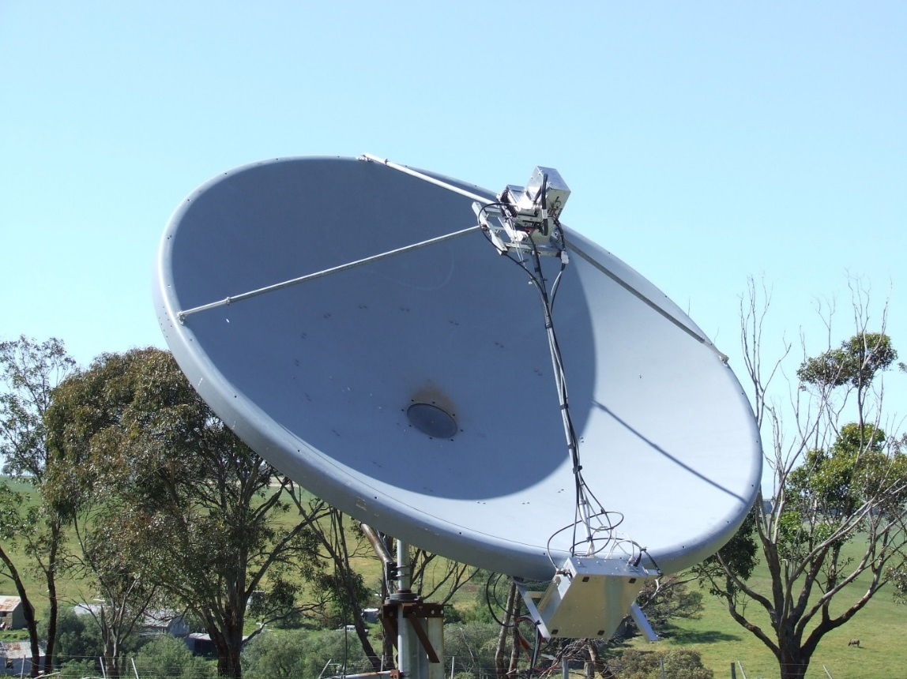

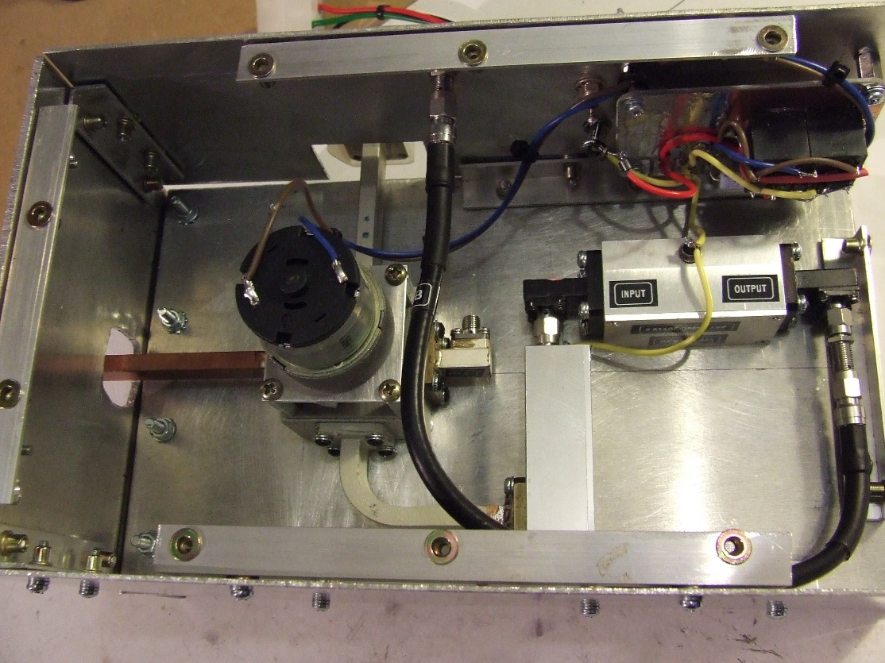

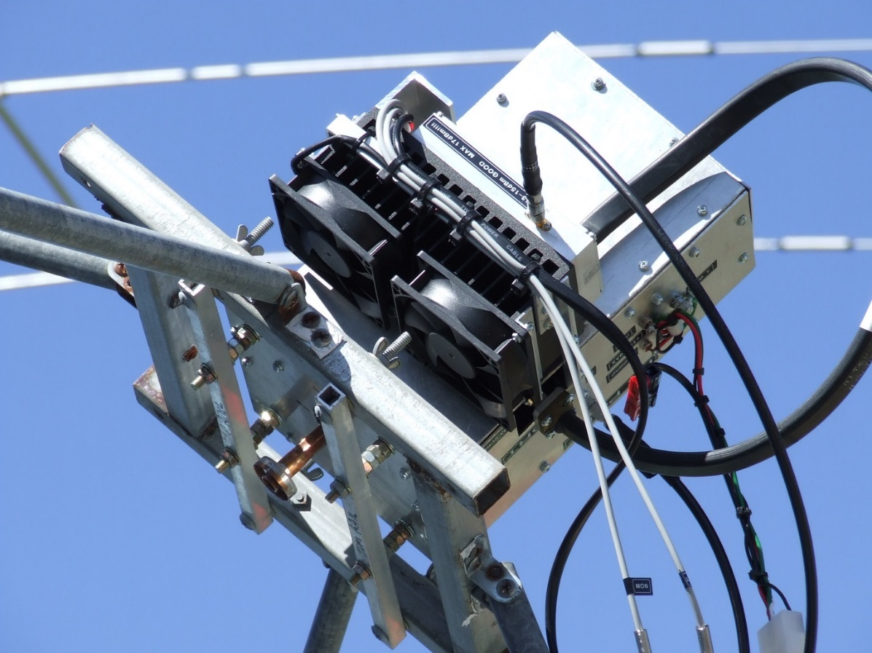

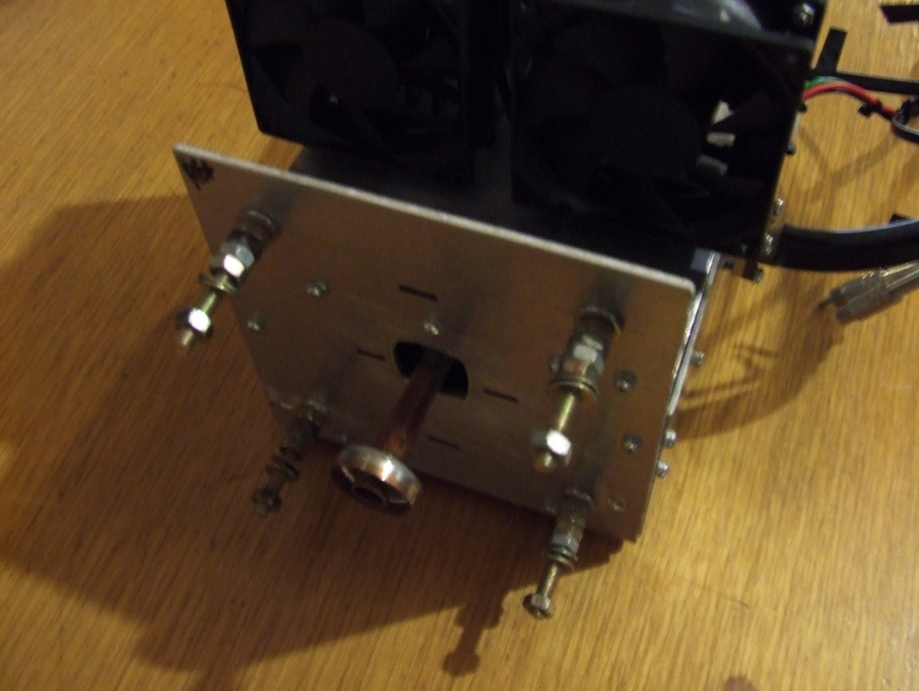

Equipment at LX1DB:

Moon noise 2,4db at time of QSO

CS/G ratio 3,4db

Dish 3m

TX 42W at the feed

Solar noise: 15,db at flux 100
moon noise: 2,5db at flux 10

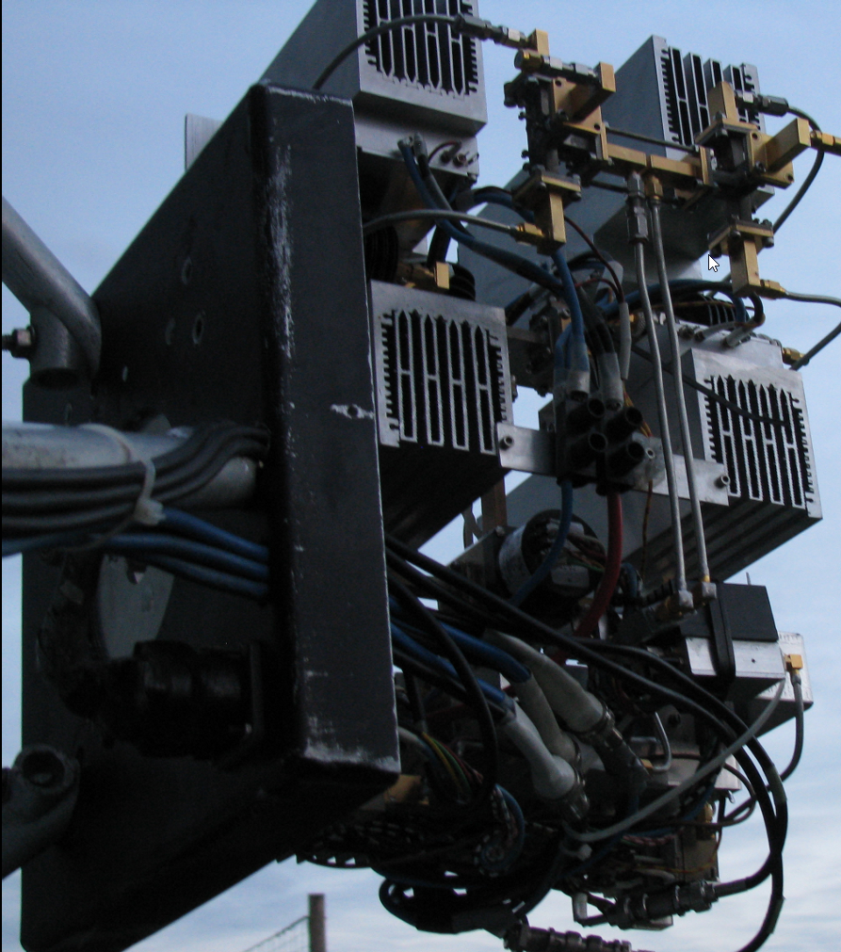

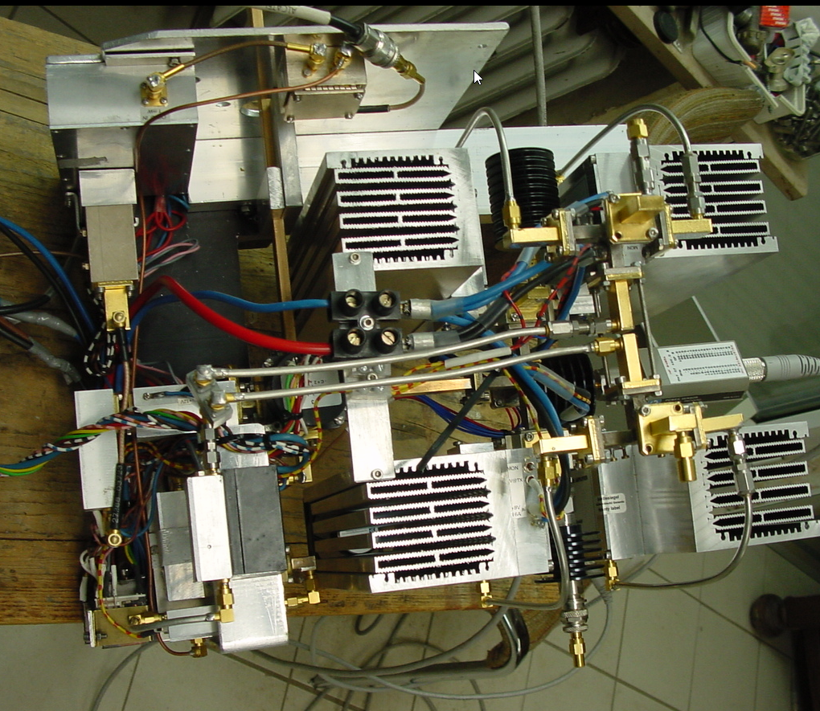

INFORMATION @ Time of QSO:

FROM VK3UM software:

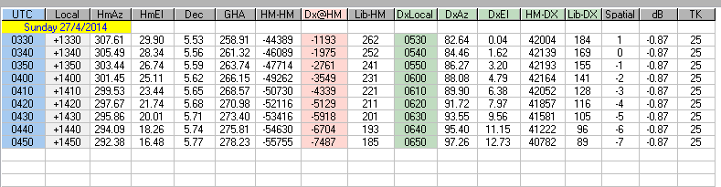

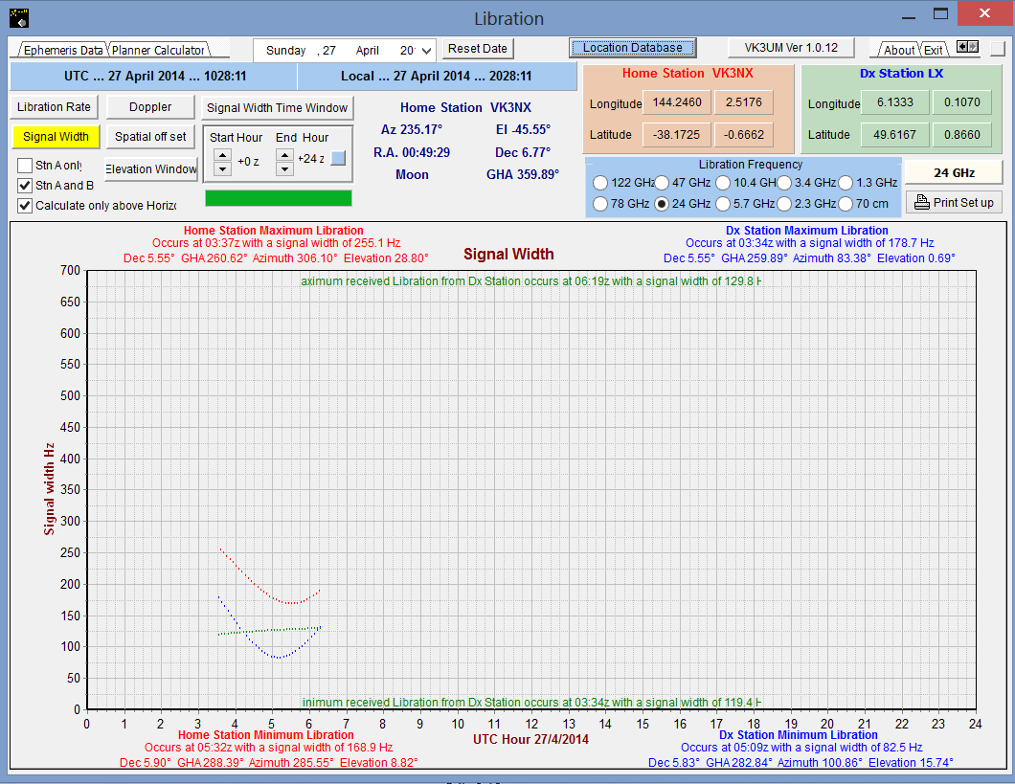
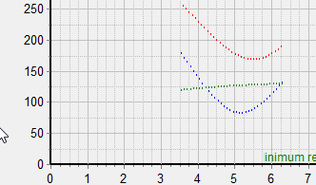

Red = VK3NX
Blue = LX1DB
Green = LX1DB @ VK3NX

Signal width of LX1DB received at VK3NX approximately 125 Hz

