13cm Feed Dimensions
(Scaled from the RA3AQ design on 1296MHz)

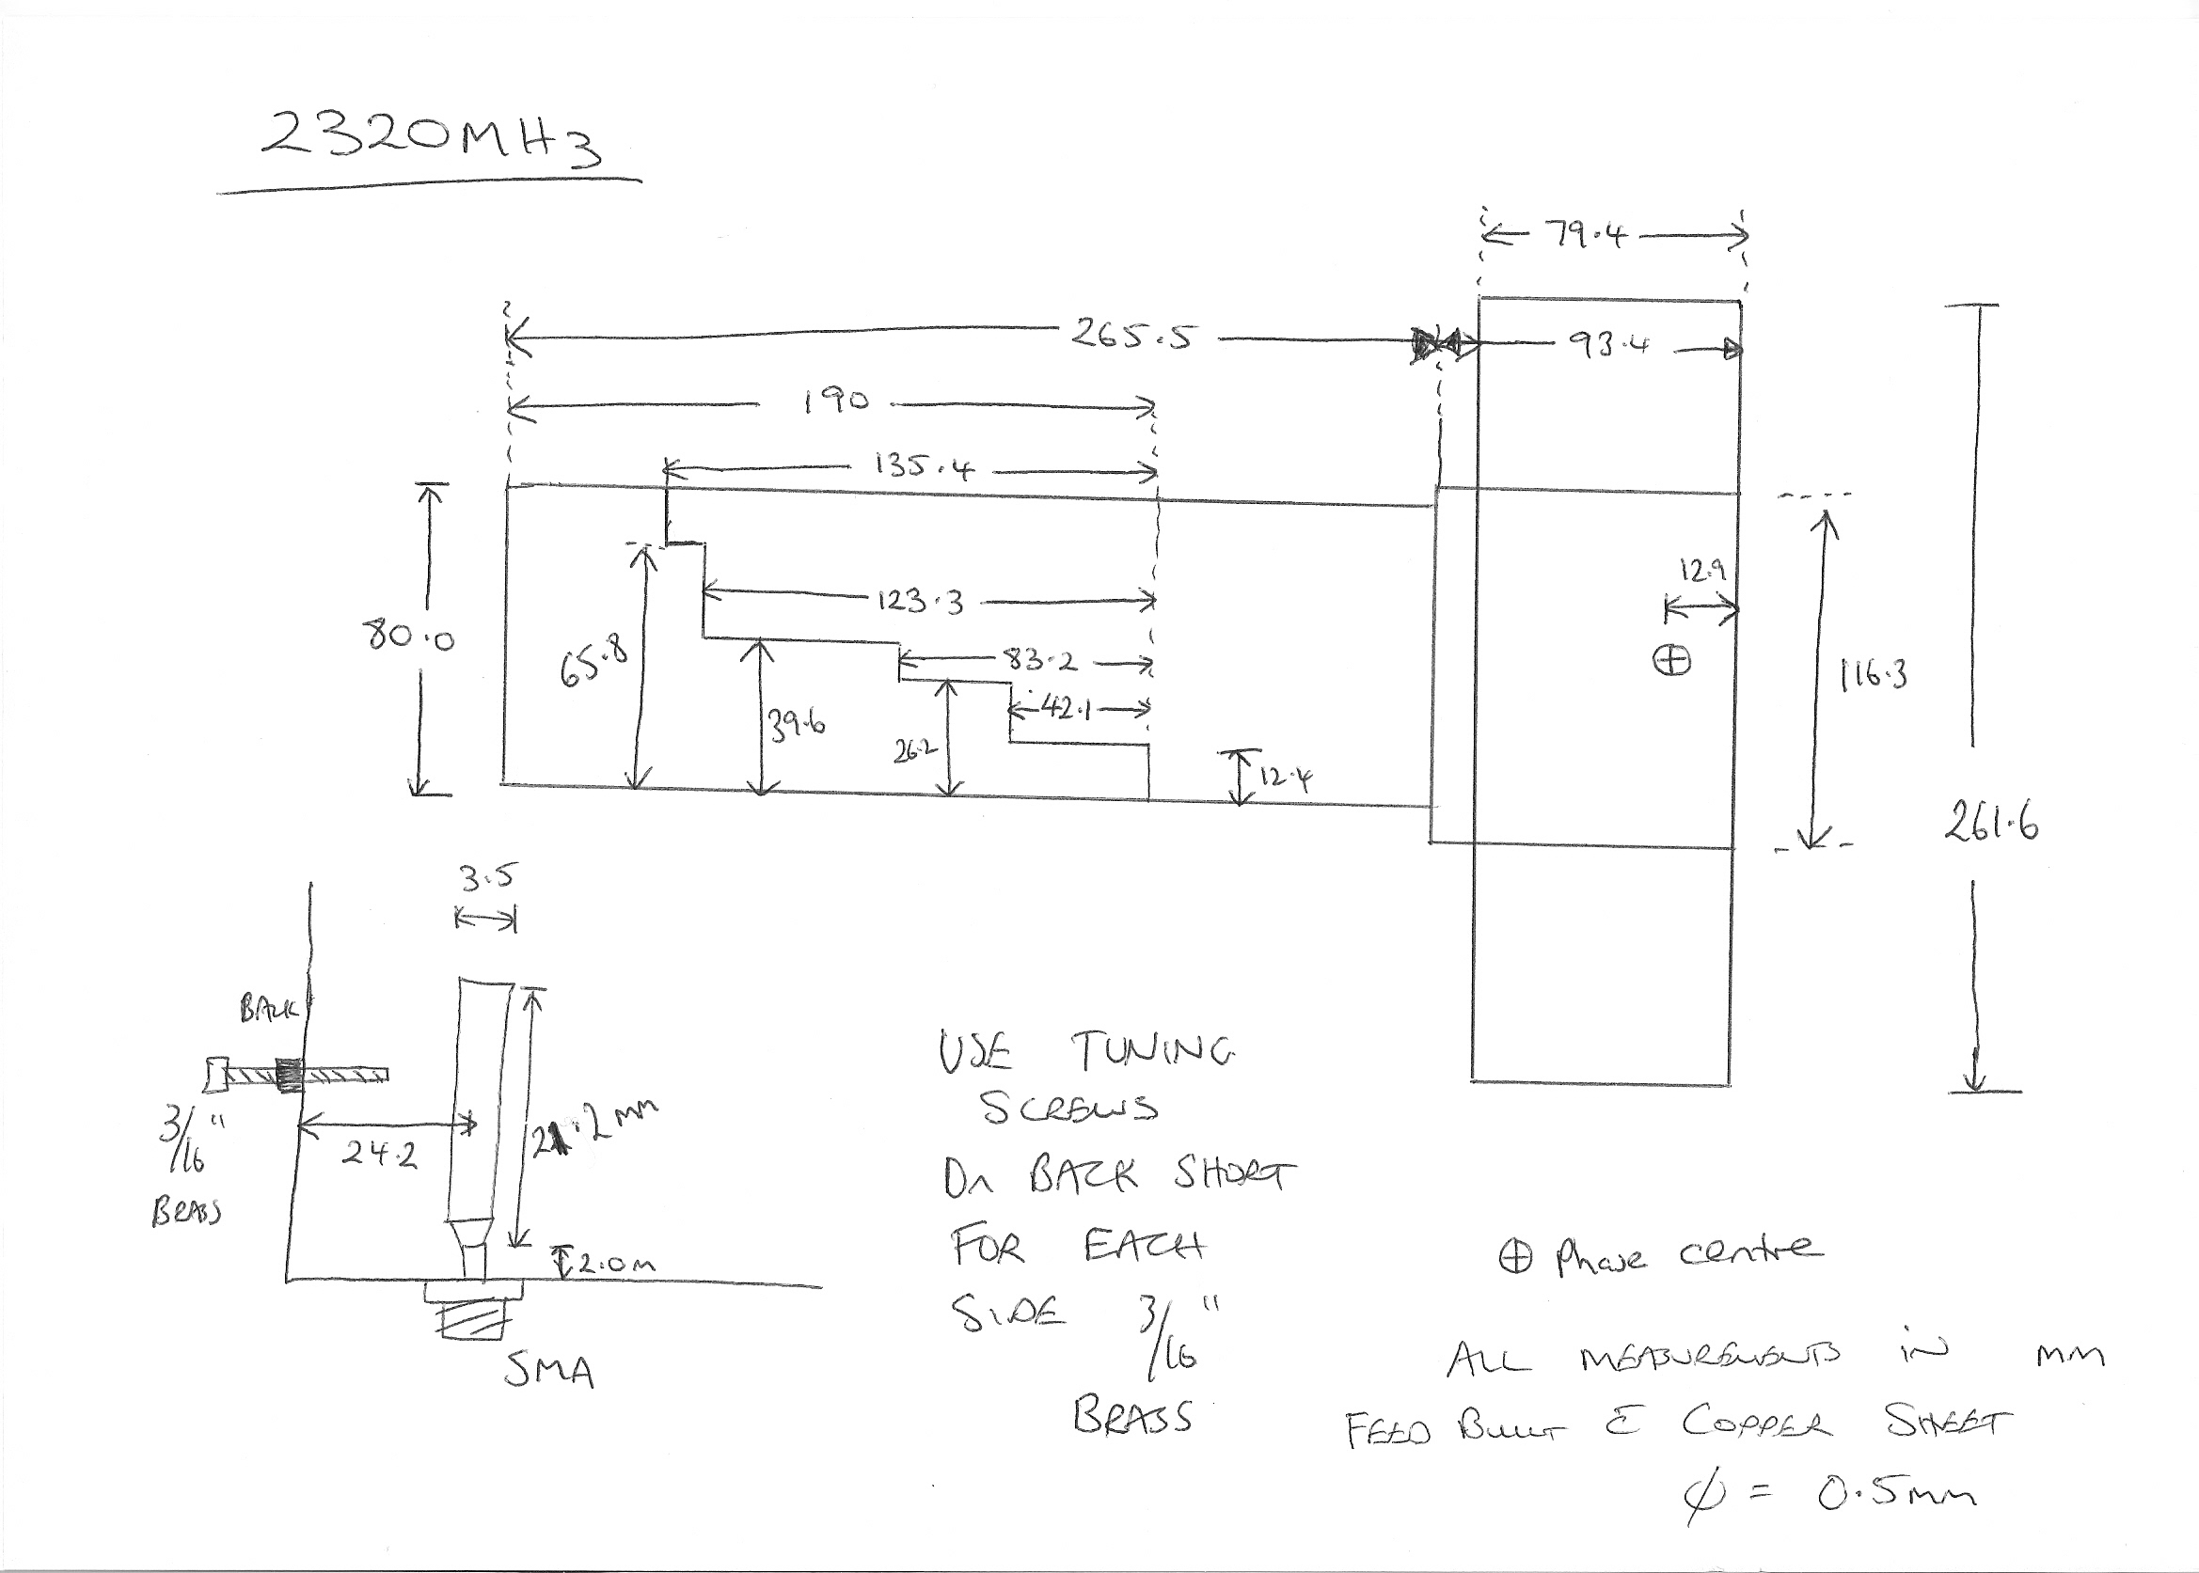

- The whole feed is built from 5mm thick copper sheet.
- The septum MUST be bonded to the back short
- “Seam soldering” produces a more consistent bond b/w the various elements
- 3/16” brass tuning screws were used as in the 1296 MHz OK1DFC septum feed
- With feed probe dimensions and positioning shown and with the tuning screws I achieved 22dB Port-Port isolation with a RL of 24dB on each port.
- Some compromise is required to achieve a balance b/w the ports for both RL and Port-Port Isolation
73 VK3NX

