VK3NX – OK1KIR QSO 16/11/2013 24 GHz JT4
CW Contact also followed
19/11/2013

Equipment VK3NX:
- 2.4 m Solid dish (Andrews)
- 11.5 W Kuhne SSPA (10 W at feed) short WR42 flexible W/G to W/G Switch (~0.5dB loss)
- Feed: Super VE4MA choke flange with Circular to rectangular transition (WR42)
- W/G switch: “EVENTS HORIZON”
- LNA @ feed
  - Kuhne 1.5dB NF 27 db gain + DB6NT design (homebrew) NF= Max 2.0dB Gain = 11.5dB
  - Total gain is 38.5dB in “feed box”
- LMR240 with Radiall 18GHz connectors for short run on Tx and Rx from “feed box” to transverter
- Transverter = Thales 26 GHz units running 1296 MHz IF. Then down-converted to 144MHz IF. IF driver IC-746. ( With 500 Hz filter used for CW contact)
- Kuhne 24 GHz W/G filters on Rx and Tx ports of Thales unit. (Absolutely necessary due to very poor image rejection ~4dB only with 1296 MHz IF)

Perfomance:
- Best Moon noise measured at 2.2dB
- Moon noise at time of sked = 1.8dB

Condx on 18/11/2013:
- Light fog / precipitation in the air.
- Humidity ~90%
- PW= 17-20mm during sked with OK1KIR (as calculated by G3WDG)

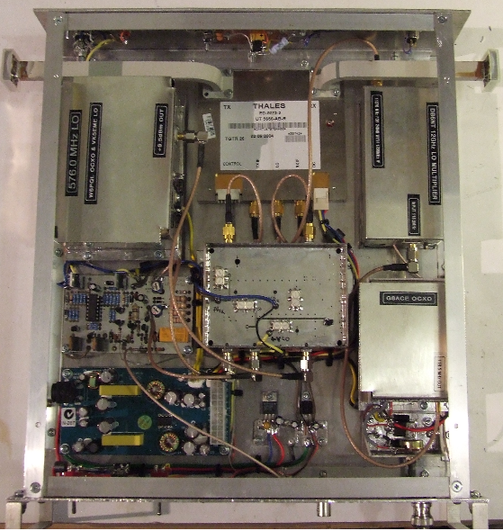

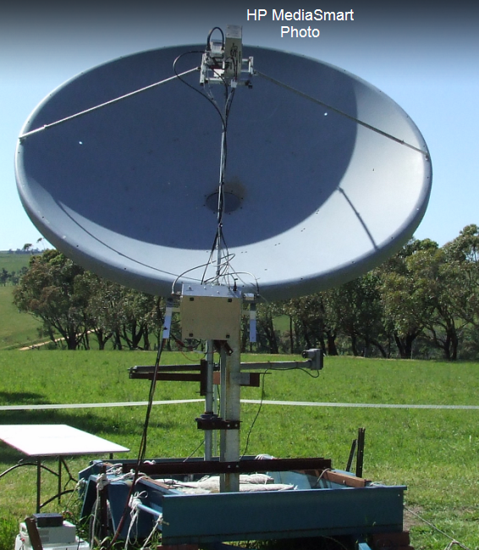

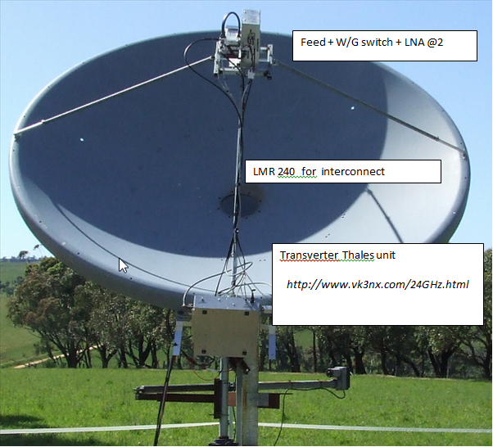

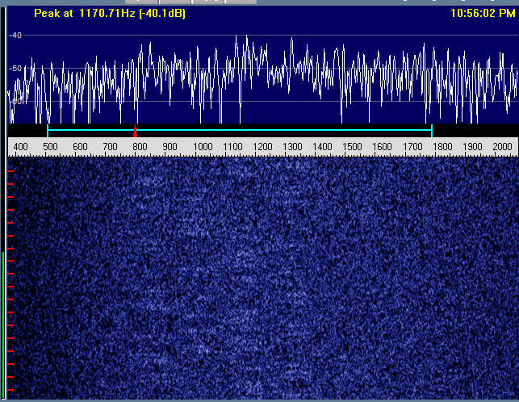

SPECTRAN view of 1558z rcvd from OK1KIR

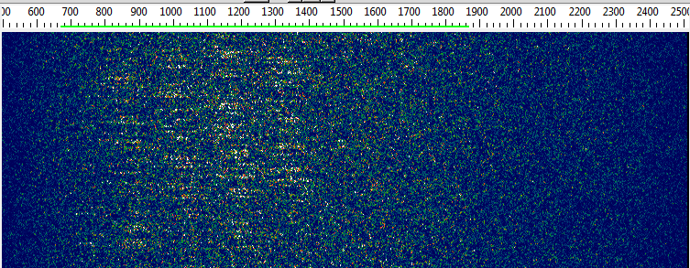

Same Signal (1558) in SpecJT

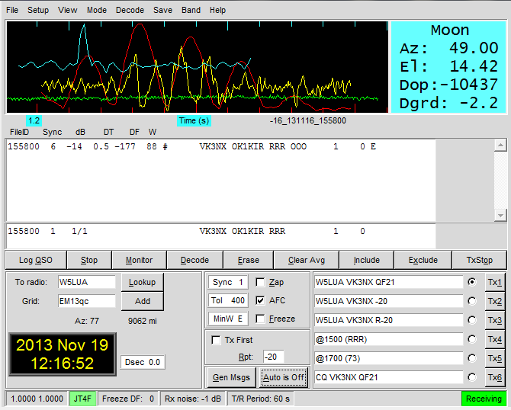

WSJT SCREEN of 1558

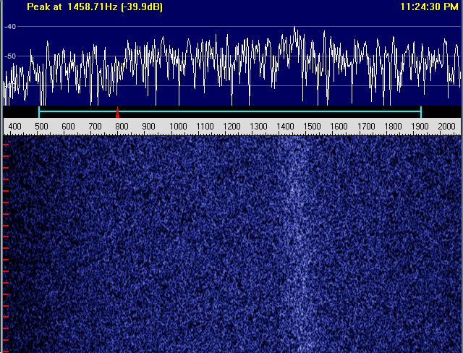
Spectran view screen of 1604z single tone

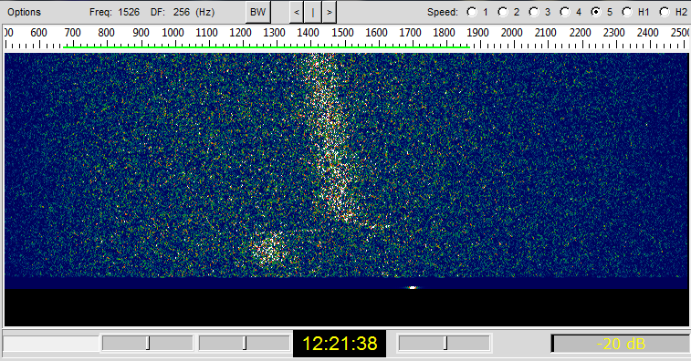

Single tone Signal at 1604z in SpecJT

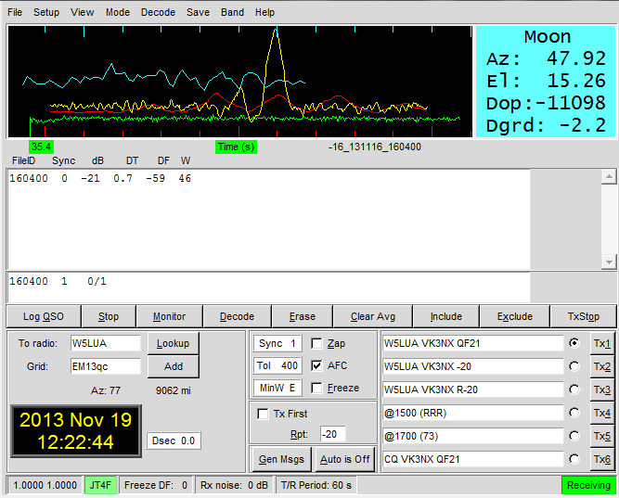

Screen Shot of 1604z

On 16/11/2013

