VK3NX – W5LUA 24 GHz CW

1st VK-USA 24GHz CW QSO

JT4F Contact also followed which was a 2nd digital QSO

Date: 14/07/2014

Report: W5LUA Received at VK3NX = O
VK3NX Received at W5LUA = M

Equipment at W5LUA:
- 2.4 m offset fed
- Pwr ~100 W from TWT
- At time of QSO… Moon noise = 1.8dB

Equipment VK3NX:
- 2.4 m Solid dish (Andrews)
- 11.5 W Kuhne SSPA (10 W at feed) short WR42 flexible W/G to W/G Switch (~0.5dB loss)
- Feed: Super VE4MA choke flange with Circular to rectangular transition (WR42)
- W/G switch: “EVENTS HORIZON”
- LNA @ feed
  - Kuhne 1.5dB NF 27 db gain + DB6NT design (homebrew) NF= Max 2.0dB Gain = 11.5dB
  - Total gain is 38.5dB in “feed box”
- LMR240 with Radiall 18GHz connectors for short run on Tx and Rx from “feed box” to transverter
- Transverter = Thales 26 GHz units running 1296 MHz IF. Then down-converted to 144MHz IF. IF driver IC-746. ( With 500 Hz filter used for CW contact)
- Kuhne 24 GHz W/G filters on Rx and Tx ports of Thales unit. (Absolutely necessary due to very poor image rejection ~4dB only with 1296 MHz IF)

Perfomance of Rx at VK3NX
- Best Moon noise measured at 2.2dB
- Moon noise at time of sked = 2.1dB

Condx at VK3NX on 14/07/2014
- Very cloudy
- Humidity ~90%
- Air temp 6 deg C
- Dew point 6.3 Deg C

Pics of VK3NX equipment:

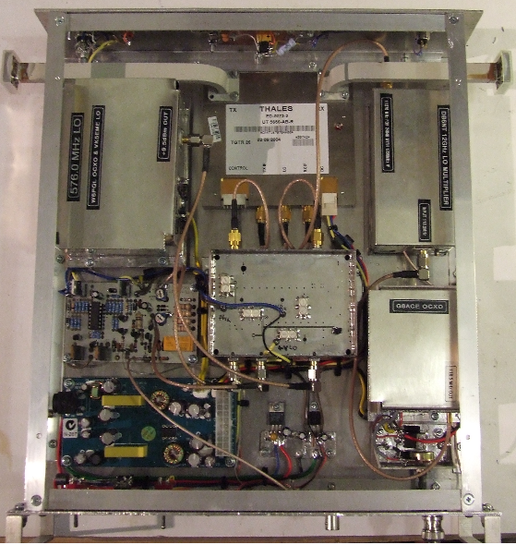

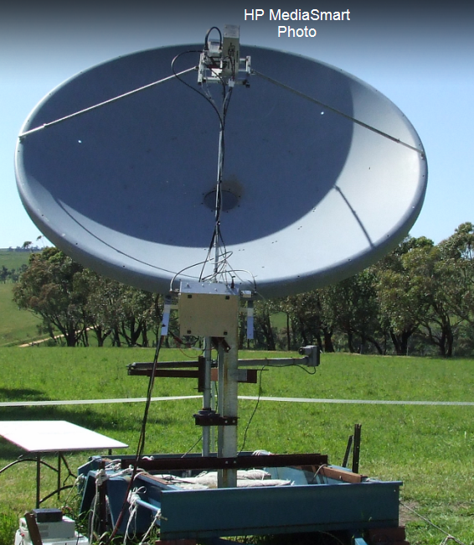

Various screen shots…..

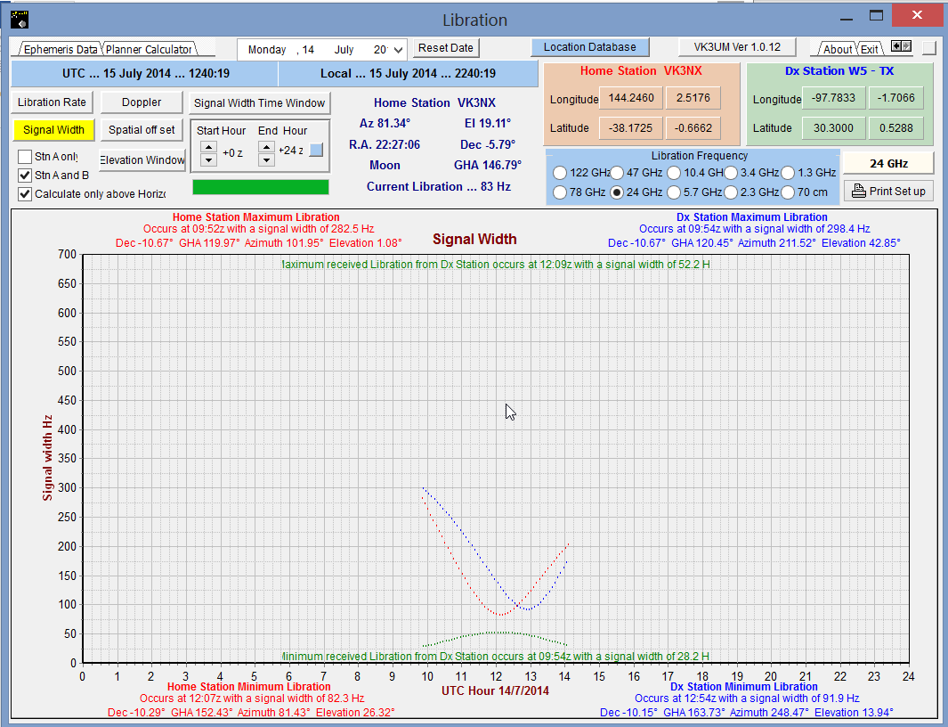

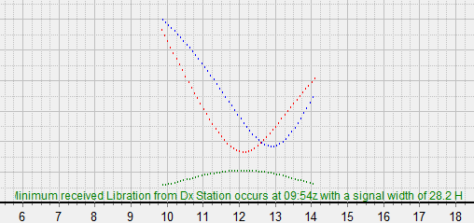

VK3UM Libration Calculator

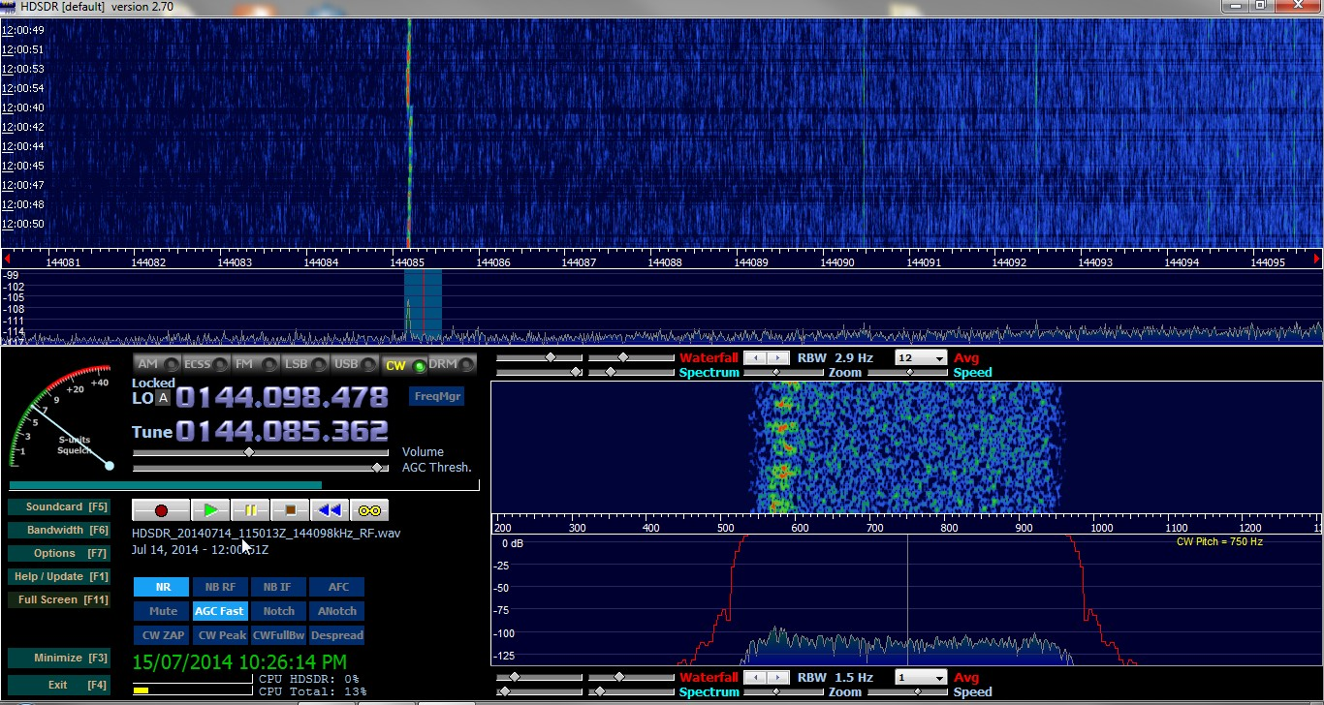

Screen Shot of W5LUA Received at VK3NX on HDSDR

