VK3NX –JA1WQF JT4F QSO REPORT

DATE : 7th Dec 2013 0940- 1000z

Wx at VK3NX Approx 20 deg Celsius 69% humidity No cloud No wind
Great circle Distance = 8212km (WSJT figure)
Elevation @ V3NX @0930z = 40 degrees @1000z= 35 degrees
Loc at VK3NX QF21CT
Loc at JA1WQF QM05AV

Equipment VK3NX:
- 2.4 m Solid dish (Andrews)
- 11.5 W Kuhne SSPA (10 W at feed) short WR42 flexible W/G to W/G Switch (~0.5dB loss)
- Feed: Super VE4MA choke flange with Circular to rectangular transition (WR42)
- W/G switch: “EVENTS HORIZON”
- LNA @ feed
  - Kuhne 1.5dB NF 27 db gain + DB6NT design (homebrew) NF= Max 2.0dB Gain = 11.5dB
  - Total gain is 38.5dB in “feed box”
- LMR240 with Radiall 18GHz connectors for short run on Tx and Rx from “feed box” to transverter
- Transverter = Thales 26 GHz units running 1296 MHz IF. Then down-converted to 144MHz IF. IF driver IC-746. ( With 500 Hz filter used for CW contact)
- Kuhne 24 GHz W/G filters on Rx and Tx ports of Thales unit. (Absolutely necessary due to very poor image rejection ~4dB only with 1296 MHz IF)

Perfomance:
- Best Moon noise measured at 2.2dB
- Moon noise at time of sked = 1.8dB

Equipment @ JA1WQF
- 2.4m dish
- Power 10 W

WSJT DECODED TEXT:

092800 0 -21 5.7 -31 22 *
092937 Transmitting: JT4F JA1WQF VK3NX QF21
092946 Transmitting: JT4F @1270

094800 7 -14 2.3 -317 96 * VK3NX JA1WQF 1 0 E
094900 Transmitting: JT4F JA1WQF VK3NX -14
095000 7 -14 2.3 -389 101 * VK3NX JA1WQF 1 0 D
095000 1 1/1 VK3NX JA1WQF 1 0
095200 4 -16 2.2 -396 90 *
095400 5 -15 2.6 -418 94 *
095600 5 -15 2.3 -365 101 * R-17 1 0 D
095700 Transmitting: JT4F JA1WQF VK3NX RRR
095800 6 -14 2.3 -438 101 * 73 1 0 D
095900 Transmitting: JT4F @1700
100000 6 -14 2.5 -466 74 *
100000 1 6/6 73 1 0
100100 0 -21 1.2 -70 7 #
100100 1 6/6 73 1 0

WSJT SCREEN SHOTS:

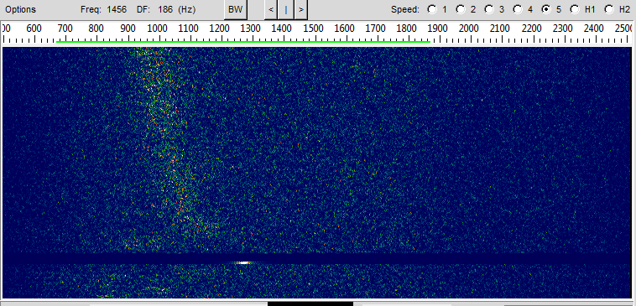

0944z JA1WQF 1270 Hz Tone

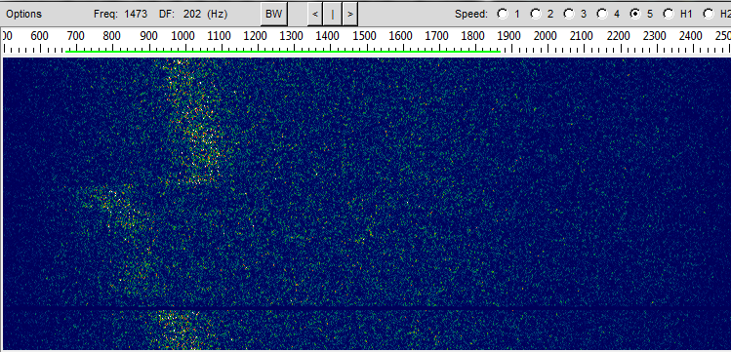

Frequency correction (netting) by VK3NX on 1270 Hz tone Rx from JA1WQF

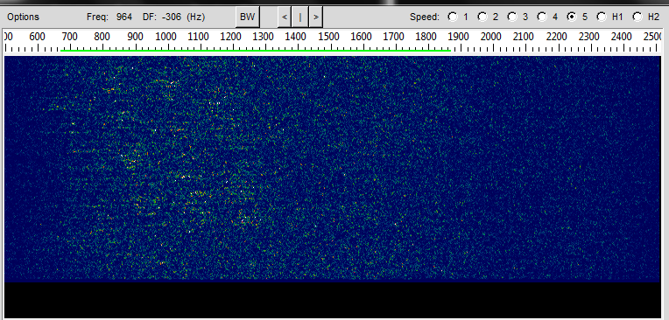

First message sent by JA1WQF @ 0948
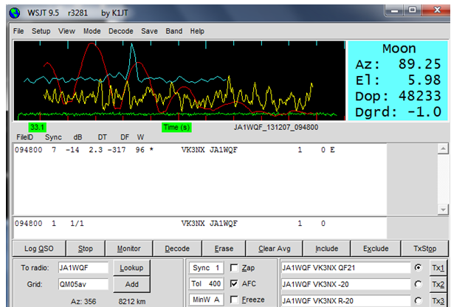

Decode of first Message. (Bin Width of “E” indicated by program for decode)

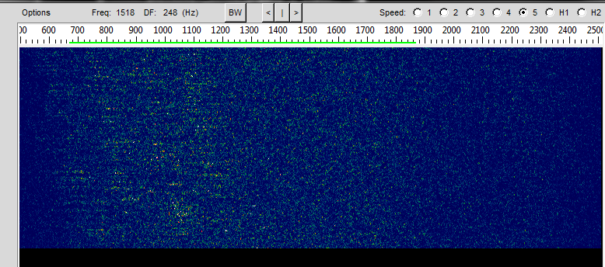

Signal at 0956

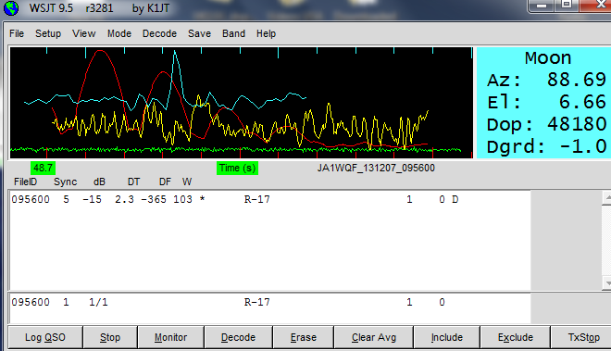

Decode @ 0956

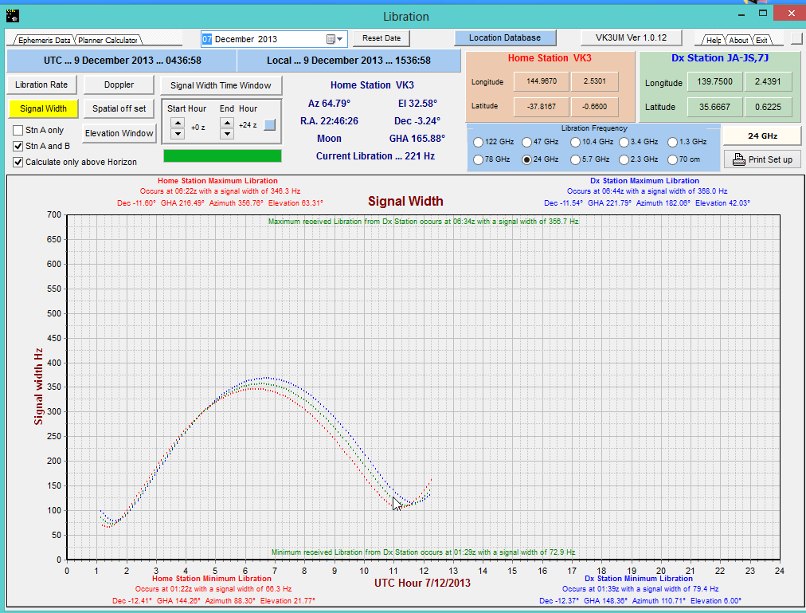

VK3UM Libration Calculator on day of sked of sked

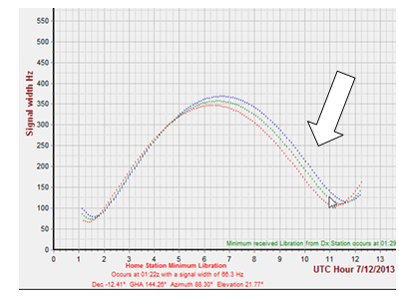
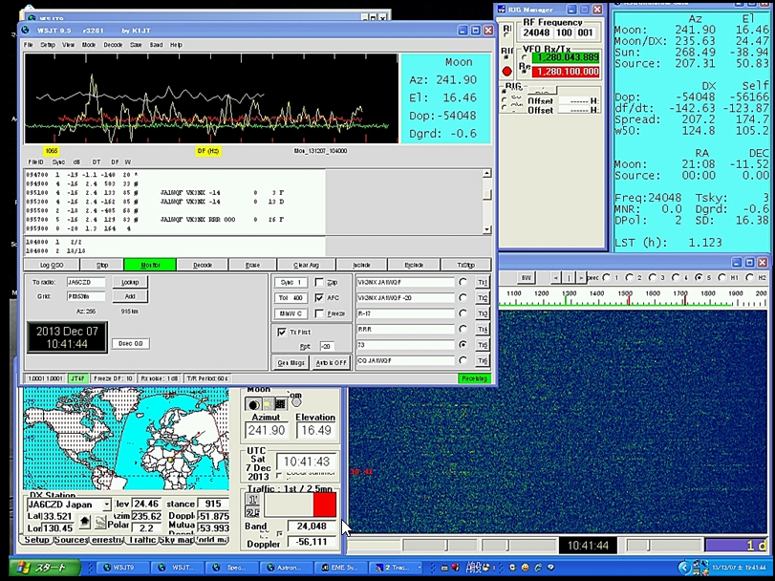

Screen shot from JA1WQF

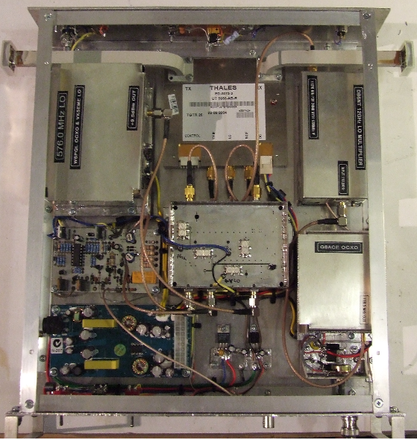
Modified Thales xvtr at VK3NX

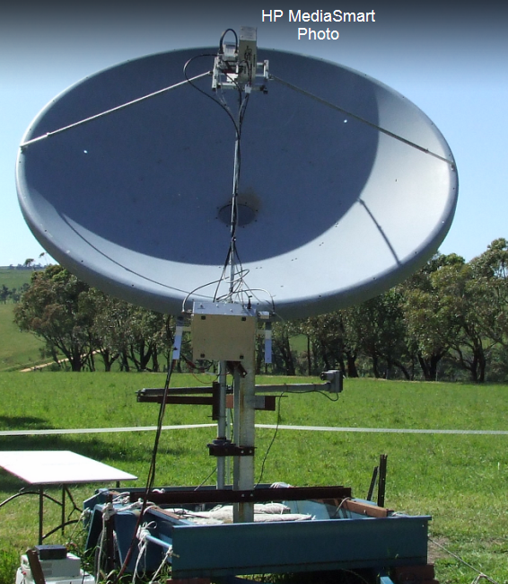

VK3NX 2.4m dish

